Ragdoll Physics

RagTest Github: https://github.com/craigzeki/RagTest
Created using these tutorials:
UNITY 2D ACTIVE RAGDOLL TUTORIAL - RUN/JUMP/GRAB/SWING
How to Make an Active 2D Stickman Ragdoll in Unity | Balance, Run, Jump

2D Ragdoll with Style in Unity

Unity ragdolls! Make your characters floppy ;)

How to make ANIMATED 2D RAGDOLL in UNITY (EASY)

2D Rigging (Skeletal Animation) A Character in Unity

Inspiration

SpiderHeck - Official Trailer



Human: Fall Flat | Gameplay trailer | PS4

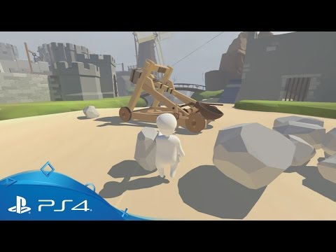

Networking

Host your Unity Multiplayer Games - Local, LAN & Eternal IP



https://docs-multiplayer.unity3d.com/netcode/current/about

How to use Unity Relay, Multiplayer through FIREWALL! (Unity Gaming Services)

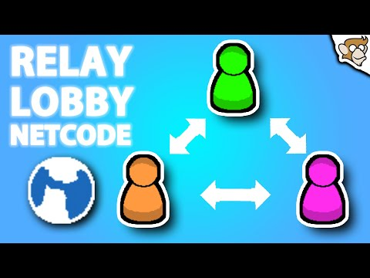

Learn Unity Multiplayer (FREE Complete Course, Netcode for Game Objects Unity Tutorial 2023)



https://blog.unity.com/games/6-community-videos-to-get-you-started-with-multiplayer

A link to a number of extra videos that are helpful for different aspects of Networking in Unity

https://github.com/VeriorPies/ParrelSync

A method to test multiplayer games on one computer (might not be needed since local play has been set up)

Miscellaneous

https://moodle.solihull.ac.uk/pluginfile.php/28106/mod_resource/content/0/Conceptual%20Document.pdf
Online document for the different sections making up a conceptual design by BJ Fogg

https://guykawasaki.com/the-only-10-slides-you-need-in-your-pitch/
Guy Kawasaki's 10/20/30 pitch deck

https://fonts.google.com/specimen/Darumadrop+One
Font for the game

Coding

https://learn.microsoft.com/en-us/dotnet/csharp/language-reference/xmldoc/examples

Example XML Documentation

https://learn.microsoft.com/en-us/dotnet/csharp/language-reference/xmldoc/recommended-tags?source=recommendations

List of XML Tags for Documentation

https://learn.microsoft.com/en-us/dotnet/csharp/language-reference/xmldoc/?source=recommendations

Extra XML Documentation Help

https://dotnet.github.io/docfx/index.html

How to use DocFX to create HTML from XML Documentation
Don't use DocFX as it is quite complex, command line only and makes a mess of the folder structure – as well as doesn't actually generate anything for our code!
Instead use Doxygen – how to here

Referencing

Use of Harvard style

Shared MyBib here: https://www.mybib.com/j/UgliestCrazyNightingale

Code Documentation Generation Using Doxygen
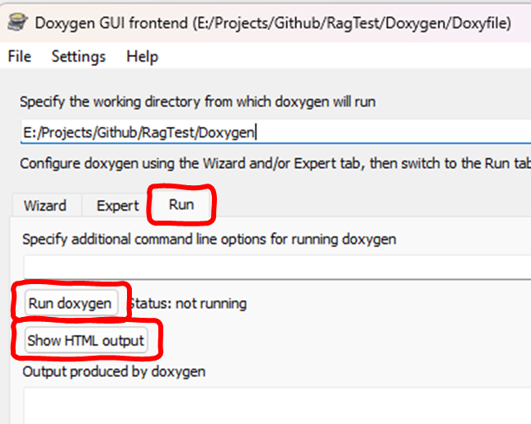

  - Download the Windows Installer of Doxygen from: https://www.doxygen.nl/
    - Note, my Microsoft Defender blocked me opening the installer as 'unrecognized' but I overrode this and so far my PC has not exploded....
    - Use this version as it comes with Doxywizard GUI app which is easier to use than the command line
  - Install using all the defaults in the installer
  - Run Doxywizard from the start menu
  - Open the Doxyfile configurartion
    - File --> Open
    - Ragtest\Doxygen\Doxyfile
  - Run Doxygen from the "Run" tab
  - Click "Show HTML Output" to view locally in your web browser
    - Check your updates are present
  - Push this to Github and let Craig know – he will upload the changes to the online version.

